- What is Michelin Lifestyle ? and what are the goals of this organization ?

Michelin Lifestyle Limited is responsible for extending the MICHELIN brand to new product categories - either directly or under trademark or technology licenses - in keeping with the Groups mission and purpose, whilst delivering value and positive experiences for the client, and remaining profitable.

- Why is Michelin selling snow chains while recommending at the same time the use of 3PMSF certified tires during winter (Winter or All Season)?

In line with its commitment Michelin is engaged on all fronts of mobility.
During the winter period, drivers can face variable and sometimes changing road conditions: dry, wet, snow, ice, slush…Depending on the frequency and the severity of the most extreme ones, we recommend to use either an All Season tire (occasional snow falls), or a Winter tire (frequent snow falls).

However, some consumers do not fit the recommended tire, and in some situation it’s mandatory to be equipped with specific winter equipment (Supplementary Grip Device – details given below). We provide a range of solutions to address the mobility in these situations.

Snow chains solutions complement our 3PMSF offers and are dedicated to extreme snowy and icy conditions. During their use, vehicles are limited in speed and distance.

- What are the regulations for snow chains in Europe?

Country | Winter tires | SGD : types | SGD : Limits & obligations | Studded tires & other remarks
France | Not compulsory | All types of SGD are authorized (auto certification) | Compulsory if road sign B26  Max. speed 50km/h | Certain mountain zones can impose the use of winter tires (« Mountain law»)
Germany | Compulsory in winter conditions (3PMSF tires or M+S tires until 2024) | Only homologated products Onorm V5117 (metal chains) | Compulsory if road sign n°268  Max. speed 50km/h | The tires must be adapted to traffic conditions (fines).  Studded tires are forbidden for all vehicles  Compulsory to have a shovel on board.
Austria | Compulsory from the 1er November to the 15th April, in winter conditions.  M+S type tires and sculpture depths greater than 4mm | Only homologated products Onorm V5117 (metal chains) or CE | Authorized from the 1/11 until the 15/04 on snow covered roads.  Compulsory if road sign B26  Max. speed 50km/h | Studded tires are authorized from the 1/10 until the 31/03 with speed limited to 80km/h on roads or 100km/h on motorways.
Italy | From the 15th October until the 15th April in northern regions (Aoste…), winter tires or snow chains must be present inside the vehicle. | Homologated SGD norm IT | Max. speed 50km/h | Studded tires are authorized from the 15/11 au 15/03 with speed limited to 90km/h on roads or 120km/h on motorways.
Switzerland | Not compulsory | Homologated SGD in accordance with the Swiss norm (ORT 14) | Authorized on snow covered roads.  Compulsory if road sign B26 | Studded tires are authorized from the 1/11 au 30/04 with speed limited to 80km/h on roads but prohibited on motorways.
United Kingdom | Not compulsory | All types of SGD allowed | Moderate speed  Only for winter road conditions | Studded tires are not regulated, authorized if winter traffic conditions (snow or black ice)
Holland | Not compulsory | All types of SGD (no regulation) | No speed limit | Studded tires are forbidden
Belgique | Not compulsory, must have the same speed index as normal tires (except from the 1/10 until the 30/04, with a visible indication of the limit for the driver) | All types of SGD (no regulation) | SGD authorized only with winter road conditions.  No speed limit | Studded tires are authorized from the 1/11 until the 31/03 with speed limited to 60km/h or 90km/h on motorways.
Sweden | Compulsory from the 1/12 until the 31/03 if in winter driving conditions or if the road is wet, normal tires are authorized all year under normal driving conditions | All types of SGD (no regulation) | No speed limit | Studded tires are authorized from the 1/10 until the 15/04, or if winter conditions. Restrictions in certain cities.  Compulsory to have a shovel on board.
Denmark | No specific rules & regulations | All types of SGD | SGD authorized only in case of snow. | Studded tires authorized from the 1/11 until the 15/04 without speed limitation.
Sources : https://www.oponeo.fr/article/pneus-d-hiver-en-europe https://www.touring.be/fr/search?search=réglementation%20chaines&f%5B0%5D=field_ref_tags%3A998
Important notice:
Update : May 2019 Take care as these regulations are submitted to frequent changes [Attention: Cette réglementation est soumise à des changements permanents].

- When do you recommend the use of snow chains ?

Snow chains can be fitted in several situations:
- When the law requires it (see example below from France)
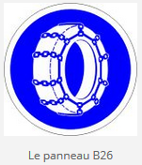

- When using a summer tire and facing snow or icy conditions (not just in the mountains)
- When you need to overcome very extreme and localized conditions

- What’s the level of a vehicle equipped with summer tires + snow chains versus a vehicle equipped with 3PMSF tires?

We focus on snow and Ice mobility only.

Conditions | Summer | Summer + SGD | 3PMSF Tyre | 3PMSF tyre + SGD | SGD gain***
Snow | X | XXX(X) | XXXXX | XXXX(XX) | -X to XXX
ICE | X | XX(XXX) | XXX | XXX(XX) | 0 to XXXX
Black road | XXXXX | X** | XXXX | X** | Usage restricted

*(X) depends on SGD. See point 6 for more details
** forbidden depending on local regulations. Refer to question 3.
*** depending of the tire on the car (summer or 3PMSF)

Please remember tires are not subjected to any speed and distance limitations.

- Below is a presentation of the snow chains portfolio offered by Michelin? and the positioning of each offer ?

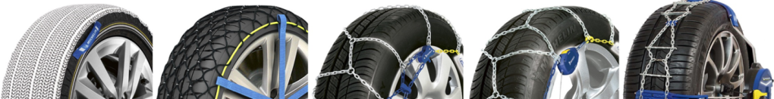

 | Summer | 3PMSF | SOS Grip | Easy Grip EVO | Extrem Grip manual | Extrem Grip automatic | Fast Grip (new 10/2019)
 | 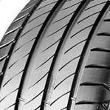 | 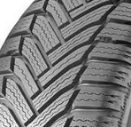 | 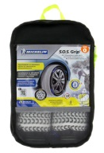 | 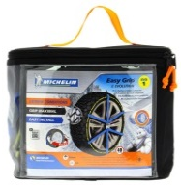 |  | 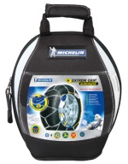 | 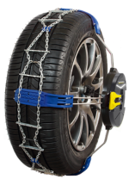
Snow  (on summer tire) | * |  | *** | **** | *** | *** | ***
ICE  (on summer tire) | * |  | ** | **** | ***** | ***** | ****
Snow  (on winter tire) |  | ***** | **** | ****** | ***** | ***** | *****
ICE  (on winter tire) |  | *** | *** | **** | ***** | ***** | ****
Ease of fitting | - | - | **** | *** | ** | *** | ****
Time to fit | - | - | ≈5min | ≈5min | ≈5min | ≈3min | ≈2min
Longevity | - | - | *** | **** | ***** | ***** | *****
Adapted to lateral chainable vehicles |  |  | No | No | No | No | Yes

- When would fitting a snow chain on a 3PMSF tire giving extra grip performance?

Snow chains solutions are a complement of our 3PMSF offers, dedicated to extreme snowy and icy conditions. On fresh snow all solutions allow to improve the snow performance of a 3PMSF tire. Even on ice, except for SOS which does not bring extra performance to a 3PMSF tire.

During their use, vehicles are limited in speed.

- What does represent our chain business today ?

Michelin offers the most complete portfolio of SGD devices on the market, (from socks, composite and metallic chains). Michelin is the only one supplier proposing a composite snow chain (Easy Grip) which has an exclusive patented Michelin technology.

In 2018, Michelin sold 140 000 pairs of SGD, which represents 30% of the global European market, and we plan to continue to grow this market with new products. For example, the new Fast Grip system will be available in winter 2019-2020.

- How is Michelin developing its SGD products?

Michelin is strongly involved in the development of its SGD products. Michelin is developing its chains using its winter testing facilities and long experience in the needs of driving in winter conditions. Constant improvements are made to develop / optimize our actual products and bring innovations to the market answering consumer needs.

